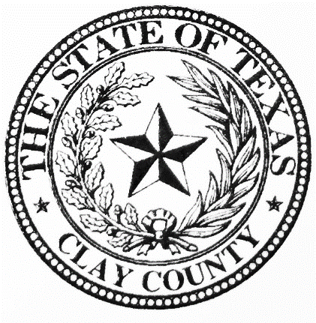
COUNTY CLERK
Sasha Kelton
Clay County Courthouse Annex - 214 N. Main Street PO Box 548, Henrietta, Texas 76365 Phone: (940) 538-4631 Fax: (940) 264-4160
ccclerk@claycountytx.com

Official Public Records Disc Request
Date: _________________________
Name: _________________________________________________________
Company name: _________________________________________________
Date range requested: ___________________ through __________________
(The clerk’s office will not hold or process requests made in advance.)
Number of discs requested: ______________________
(If requesting more than one month per disc, contact County Clerk for instructions)

________________________________________
Authorized signature of requestor

For office use only
Request received by: _____________________________, Deputy Clerk
Date: __________________________ at ______:______ ___.m.
CD delivered by (HAND) or (MAIL) on _________________________

